

**ใบงาน ชุดที่ 3**

**สถานแสงดพันธุ์สัตว์น้ำ ภูเก็ต**

**51 หมู่ 8 ถ.ศักดิเดช ต.วิชิต อ.เมือง จ.ภูเก็ต 83000 โทร 076 391 126 โทรสาร 076 391406**

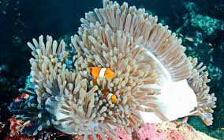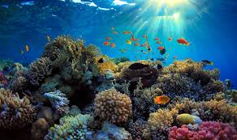

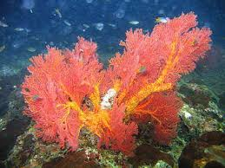

**ปะการัง คือ** .................................................................................................................................................................

................................................................................................................................................................................................

...............................................................................................................................................................................................

................................................................................................................................................................................................

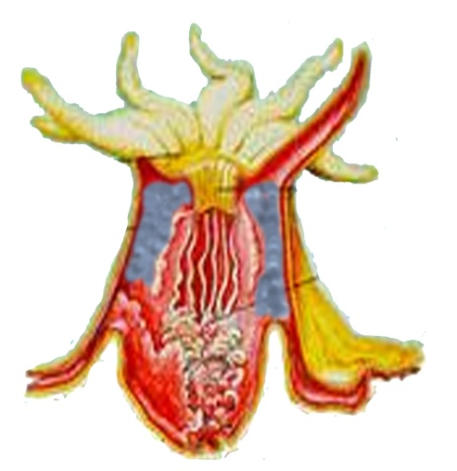

**ประโยชน์ของแนวปะการัง** .................................................................................................................

....................................................................................................................................................................

..................................................................................................................................................................

**ส่วนประกอบของปะการัง..............................................**

**.....................................................................................**

**....................................................................................**

**.....................................................................................**